**ASSIGNMENT - 16.6**

**Problem Statement:**

Write a map reduce program to join the below given two datasets using Reducer side join.

**Input Data Set:**

<https://drive.google.com/open?id=0ByJLBTmJojjzSWhfXzI5NGh4RGM>

Dataset description of dataset1.csv is as follows: id,first_name,last_name,email,gender,ip_address

Dataset description of tdataset2.csv is as follows: id,first_name,last_name

**Program:**

**Driver Class:**

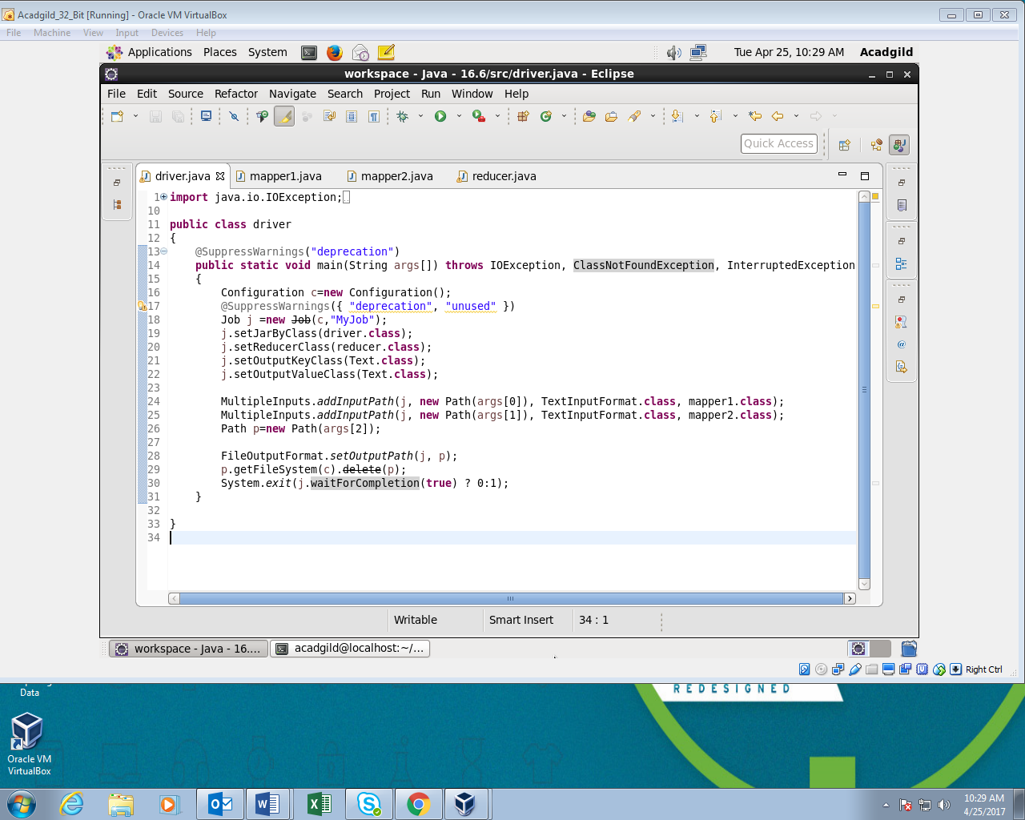

**Mapper1 Class:**

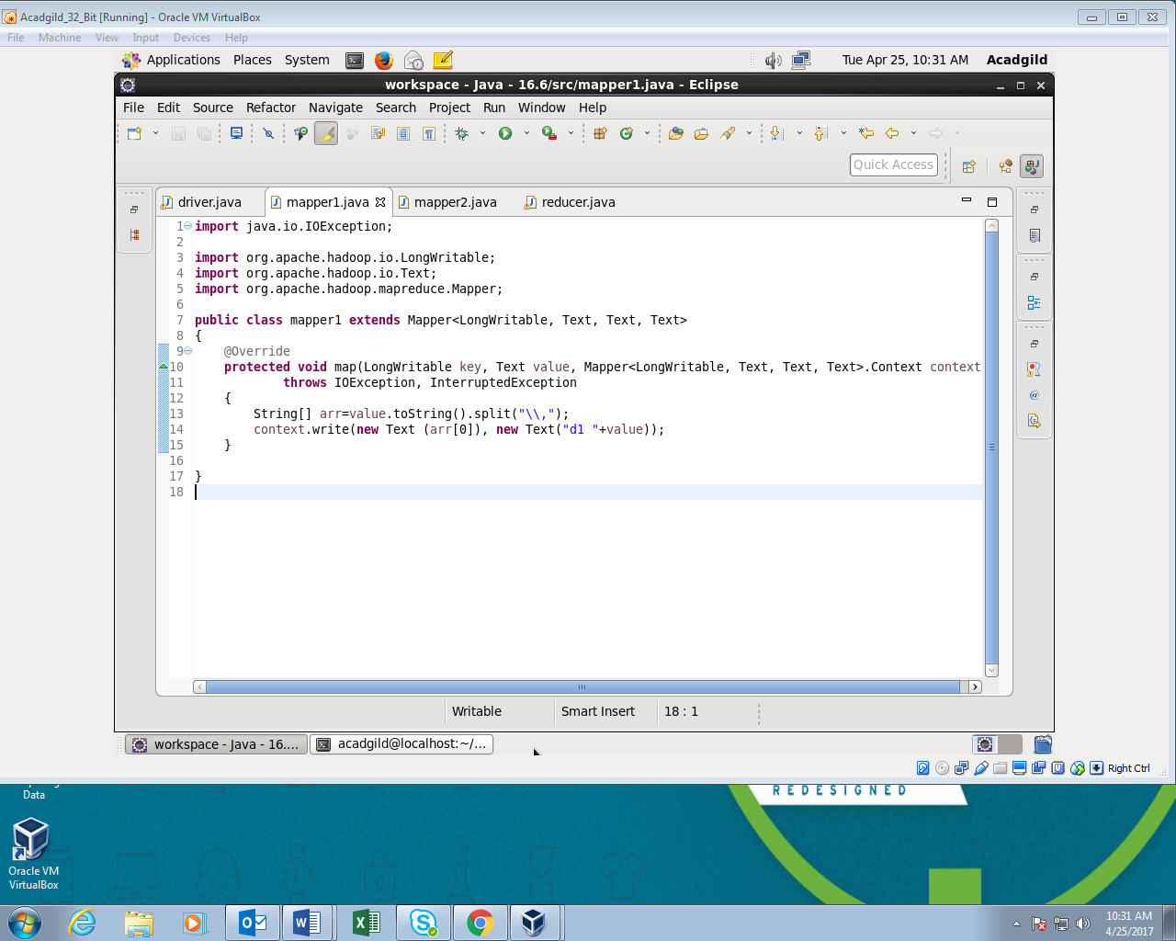

**Mapper2 Class:**

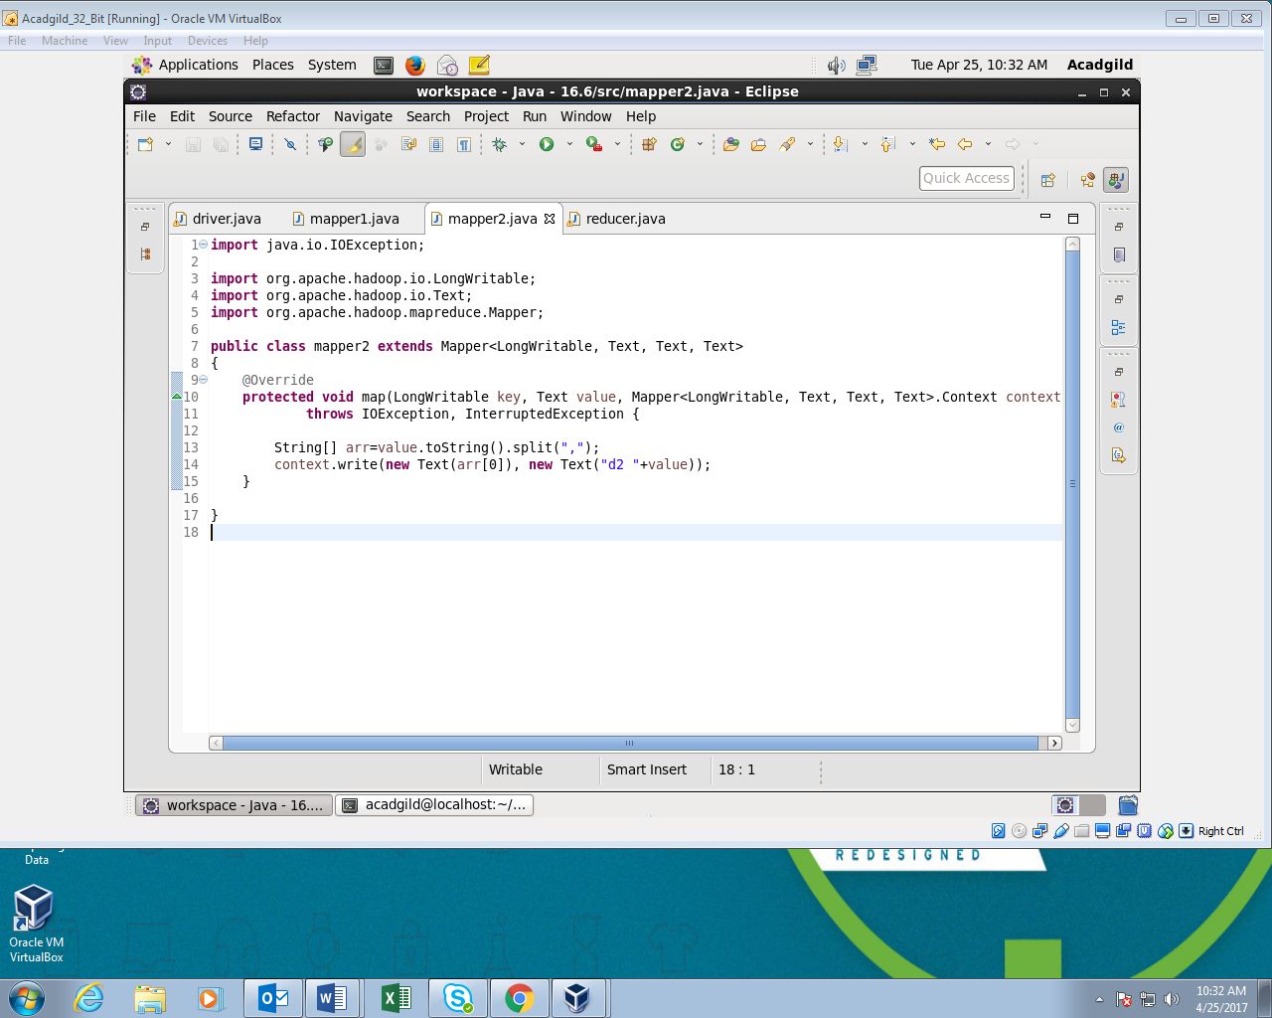

**Reducer Class:**

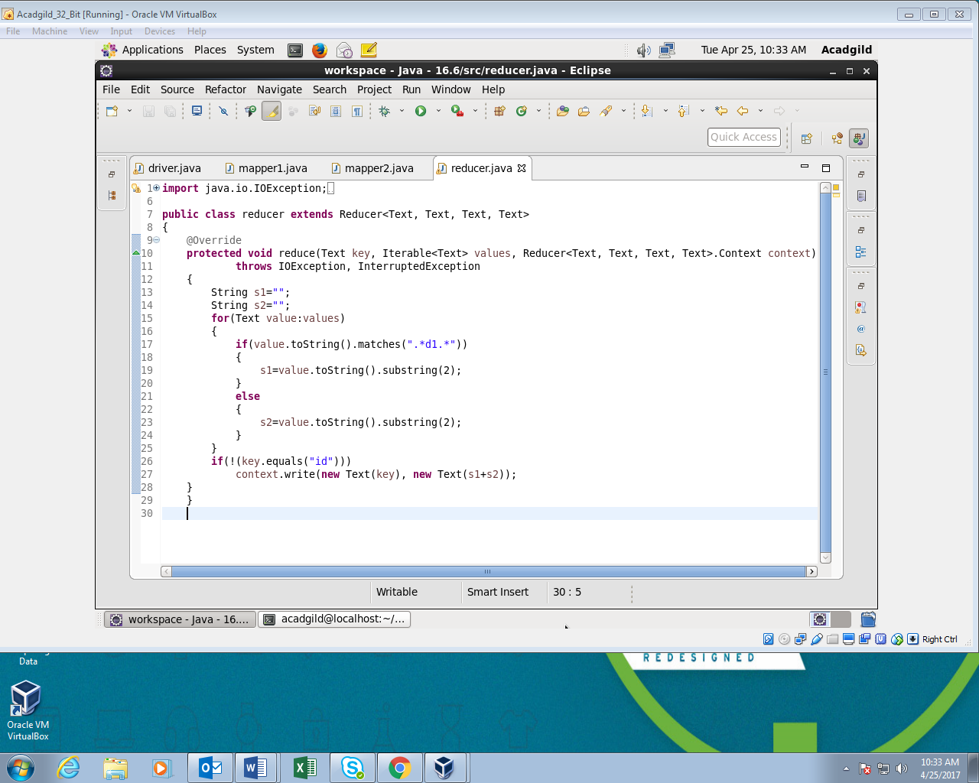

**Output:**

The records from dataset1.csv and dataset2.csv are joined using common field in both the datasets which is id.

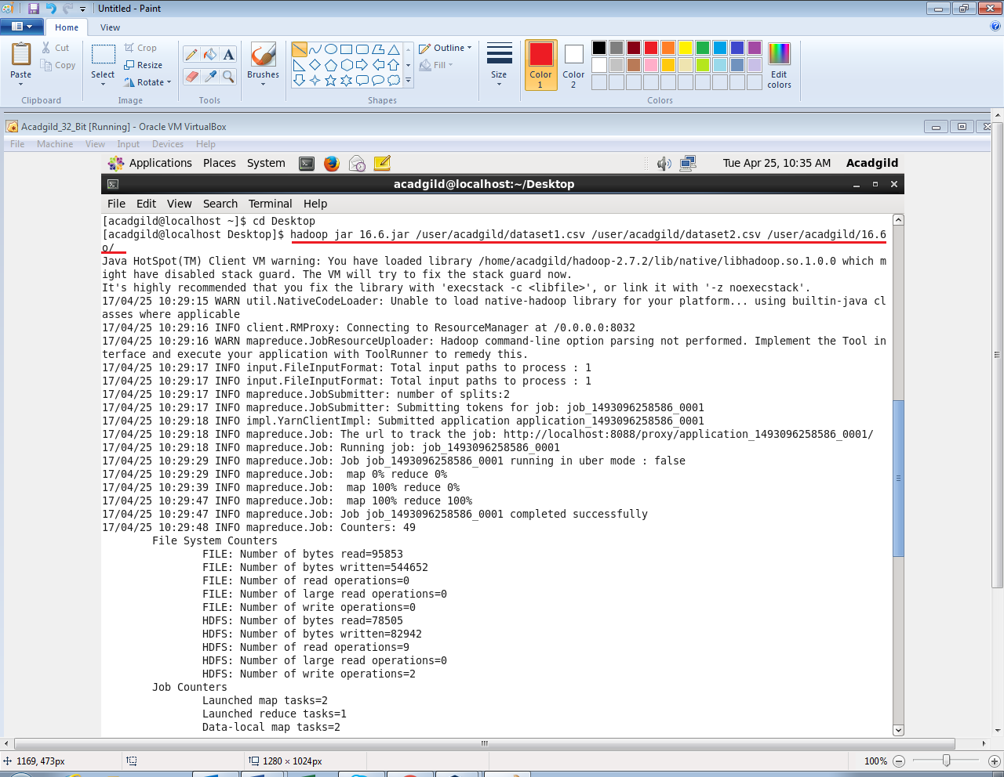

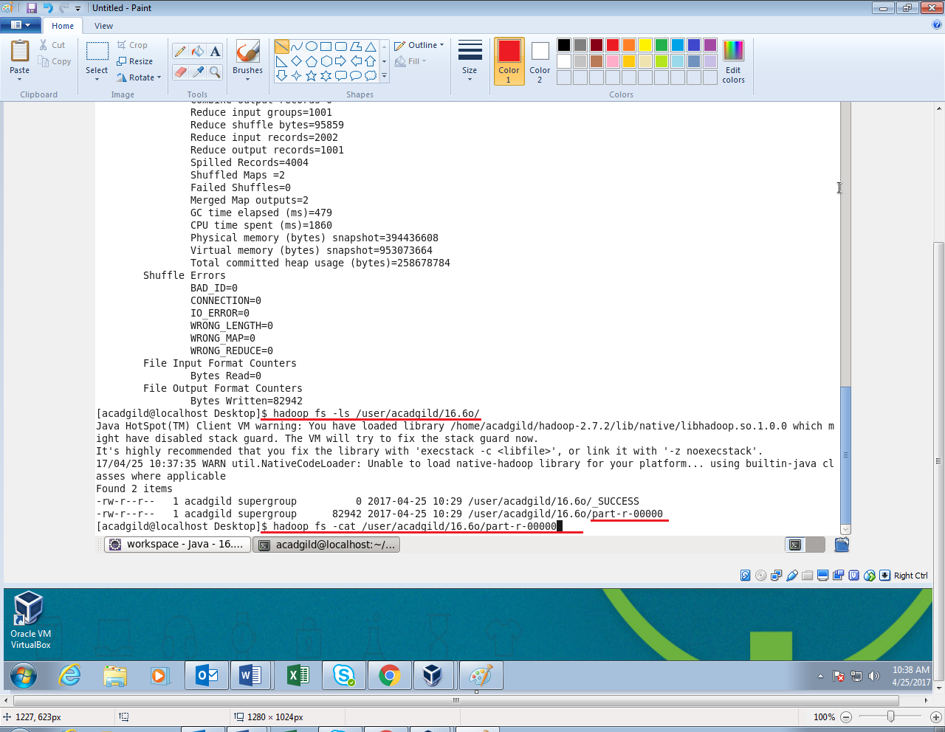

**As the output consists of large number of records screenshot of last few records is attached below:**

